**Energy Skate Park**

**APP1 Lab #1 Unit Objectives:**

* Explain and apply the Law of Conservation of Energy (CLO1)(CLO2)(CLO3)(CLO5)(CLO6)
* Define energy, kinetic energy, and gravitational potential energy (CLO2)(CLO3)
* Analyze situations that involve kinetic and potential energy. (CLO2)(CLO3)
* Calculate kinetic and potential energies. (CLO2)(CLO5)

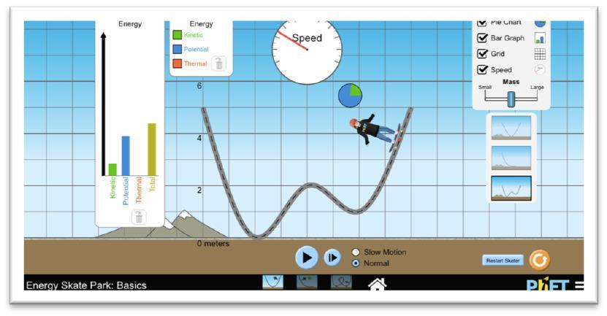

* Open the [*Energy Skate Park* PhET Simulation](https://phet.colorado.edu/en/simulation/energy-skate-park-basics) https://phet.colorado.edu/en/simulation/energyskate-park-basics
* Grab a timer.

# Purpose

You are investigating the relationship between kinetic energy, potential energy, and total energy when only conservative forces are present and then again when non-conservative forces are present. The data will be analyzed graphically in order to provide a clear trend.

# Directions

## Part 1- Conservative Forces

1. Open *Energy Skate Park*. Choose *Intro*.

1. Take time to play around with the simulation. Make sure all boxes are checked.

* + What do you notice about the total energy, kinetic energy, and potential energy in the bar graph?

* + What do you notice about the pie graph? What must you do in order to get the pie graph to be larger?

1. You are measuring the changes in energy- total, kinetic, and potential over time. To do this, we need to define our system. **This is a skater-earth system**.

1. We also need to establish numbers for mass and speed.

1. 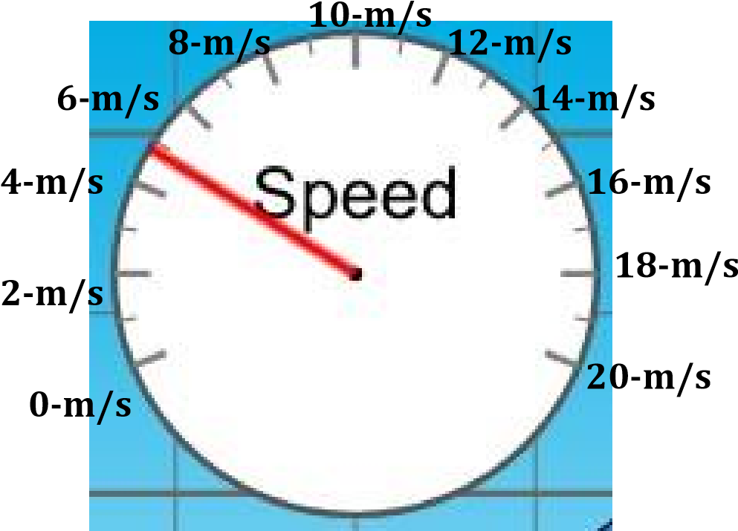Place the 10-kg skater at 6-m and start the timer when you hit play. Pause both timer and sim when the skater is at 4-m, 2-m, 0-m, and 6-m. Record the height, speed, and time in the table below. Continue recording until you’ve reached 45-s.

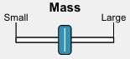

**5**



**-**



**kg**



**10**



**-**



**kg**



**15**



**-**



**kg**



|  |  |  |
| --- | --- | --- |
| **Time** | **Height** | **Velocity** |
| 0-s | 6-m | 0-m/s |
|  |  |  |
|  |  |  |
|  |  |  |
|  |  |  |
|  |  |  |
|  |  |  |
|  |  |  |
|  |  |  |
|  |  |  |
|  |  |  |
|  |  |  |
|  |  |  |
|  |  |  |
|  |  |  |
|  |  |  |
|  |  |  |
|  |  |  |
|  |  |  |
|  |  |  |

1. Calculate the potential energy, kinetic energy, and total energy of the system using the data from #4.

|  |  |  |  |
| --- | --- | --- | --- |
| Time (x-axis) | Potential Energy (yaxis) | Kinetic Energy (y-axis) | Total Energy (y-axis) |
|  |  |  |  |
|  |  |  |  |
|  |  |  |  |
|  |  |  |  |
|  |  |  |  |
|  |  |  |  |
|  |  |  |  |
|  |  |  |  |
|  |  |  |  |
|  |  |  |  |
|  |  |  |  |
|  |  |  |  |
|  |  |  |  |
|  |  |  |  |
|  |  |  |  |
|  |  |  |  |
|  |  |  |  |
|  |  |  |  |
|  |  |  |  |
|  |  |  |  |

1. Graph the three data sets in #5. I have attached an instructional video to the assignment to help with this step.

## Part 2- Non-conservative Forces

1. Click “Friction” at the bottom of the simulation.

1. Take time to play around with this simulation. Make sure all boxes are checked.

* + What do you notice about the total energy, kinetic energy, and potential energy in the bar graph?

* + What do you notice about the final thermal energy & the total energy once the skater has stopped?

1. You are measuring the changes in energy- total, kinetic, and potential over time. To do this, we need to establish numbers for mass and speed as well as our system: This is a **skater-earth** **system**.

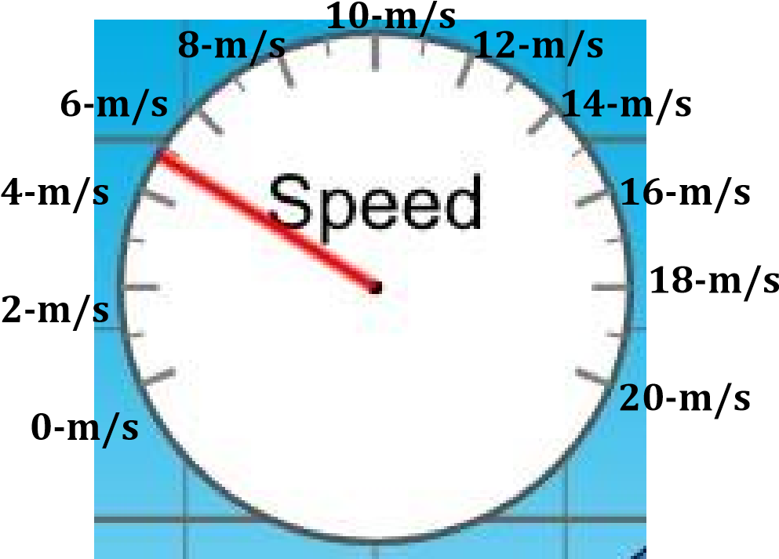



**5**



**-**



**kg**



**10**



**-**



**kg**



**15**



**-**



**kg**



1. Place the 10-kg skater at 6-m and start the timer when you hit play. Pause both timer and sim when the skater is at 4-m, 2-m, 0-m, and 6-m. Record the height, speed, and time in the table below. Continue recording until you’ve reached 45-s.

|  |  |  |
| --- | --- | --- |
| **Time** | **Height** | **Velocity** |
| 0-s | 6-m | 0-m/s |
|  |  |  |
|  |  |  |
|  |  |  |
|  |  |  |
|  |  |  |
|  |  |  |
|  |  |  |
|  |  |  |
|  |  |  |
|  |  |  |
|  |  |  |
|  |  |  |
|  |  |  |
|  |  |  |
|  |  |  |
|  |  |  |
|  |  |  |
|  |  |  |
|  |  |  |

1. Calculate the potential energy, kinetic energy, and total energy of the system using the data from #10.

|  |  |  |  |  |
| --- | --- | --- | --- | --- |
| Time (x-axis) | Potential Energy (y-axis) | Kinetic Energy (y-axis) | Thermal Energy  (y-axis) | Total Energy (yaxis) |
|  |  |  |  |  |
|  |  |  |  |  |
|  |  |  |  |  |
|  |  |  |  |  |
|  |  |  |  |  |
|  |  |  |  |  |
|  |  |  |  |  |
|  |  |  |  |  |
|  |  |  |  |  |
|  |  |  |  |  |
|  |  |  |  |  |
|  |  |  |  |  |
|  |  |  |  |  |
|  |  |  |  |  |
|  |  |  |  |  |
|  |  |  |  |  |
|  |  |  |  |  |
|  |  |  |  |  |
|  |  |  |  |  |
|  |  |  |  |  |

1. Graph the four data sets in #11. Follow the same procedure as before. Make the thermal energy a linear fit.

1. You are now finished with the experiment itself. Now type a formal lab report to present this information. Be sure to follow the rubric for the lab report attached to this assignment.