# Bonding & Molecular Geometry Experiment

**This activity supports the following unit and course objectives:**

(CLO4) Demonstrate knowledge of basic laboratory skills and operations in the areas of safety, measurement, chemical and physical properties of matter, atomic and molecular structure, chemical reactions, reactivity, structure, periodicity, and bonding.

Lewis Symbols and Structure (4.4)

* (4.4.1) Write Lewis symbols for neutral atoms and ions (CLO2)
* (4.4.2) Draw Lewis structures depicting the bonding in simple molecules (CLO2)

**In addition to the unit and course objectives, this activity supports the following activity objectives:**

* Draw molecular shapes (4.4.2)

**Background:**

When learning how to draw structural formulas it is difficult to visualize the actual geometry or shape of the molecule when it is drawn on paper. When you draw a molecule on paper, you are only seeing a 2-dimensional representation of it. Molecular model kits and virtual simulations allow you the opportunity to gain a more accurate perception of a molecule’s actual geometry in three dimensions.

**Part 1: Lewis Diagrams**

1. Watch the following tutorial on drawing Lewis dot diagrams for covalent molecules.

[Lewis Diagrams Tutorial: How to Draw Lewis Dot Structures](https://edpuzzle.com/media/5c2f70811be7af406e5160d5)

2. Draw the Lewis structures for the following molecules. Pay attention to possible double and triple bonds!

|  | Lewis diagram |
| --- | --- |
| O2 |  |
| H2 |  |
| Cl2 |  |
| N2 |  |
| H2O |  |
| CO2 |  |
| CO |  |
| NH3 |  |
| PH3 |  |
| CH4 |  |

**Part 2: Molecular Shapes**

1. Visit the following [PHET simulation Build a Molecule](https://phet.colorado.edu/sims/html/build-a-molecule/latest/build-a-molecule_en.html) and go to the “Playground.”

2. Sketch the 3-D model of the molecule. Make sure you view the “ball and stick” views under the 3D tab. Click the to reset between models.

|  |  |  |
| --- | --- | --- |
|  | **“Ball and Stick”**  **Sketch of the Molecule** | **Shape of Molecule** |
| O2 |  |  |
| H2 |  |  |
| Cl2 |  |  |
| N2 |  |  |
| H2O |  |  |
| SO2 |  |  |
| CO2 |  |  |
| CO |  |  |
| NH3 |  |  |
| PH3 |  |  |
| CH4 |  |  |

**Questions:**

1. Which of the molecules that you built were polar? Explain your reasoning.

2. Which of the molecules that you built were nonpolar? Explain your reasoning.

# Molecule Polarity Experiment

**This activity supports the following unit and course objectives:**

Molecular Structure and Polarity (4.6)

* (4.6.2) Explain the concepts of polar covalent bonds and molecular polarity (CLO1)
* (4.6.3) Assess the polarity of a molecule based on its bonding and structure (CLO2)

**In addition to the unit and course objectives, this activity supports the following activity objectives:**

* Discuss the factors that affect polarity (4.6.2) (4.6.3)

**Part I: What factors affect molecule polarity?**

1. Explore the [Molecule Polarity](https://phet.colorado.edu/en/simulations/molecule-polarity)simulation for a few minutes with a partner. In each of the three tabs, try to find all of the controls and figure out how they work.

**Two Atoms** tab

1. Describe all of the ways you can change the polarity of the two-atom molecule.
2. Explain how the representations below help you understand molecule polarity.

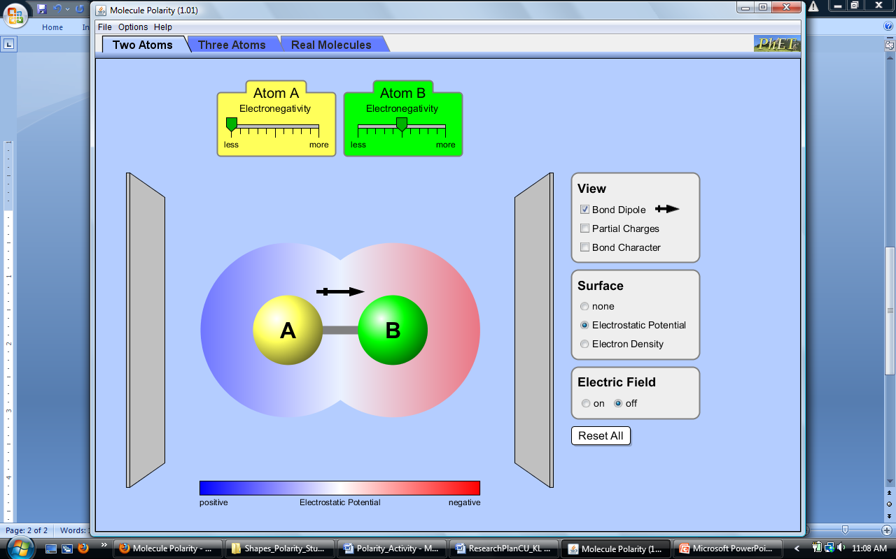

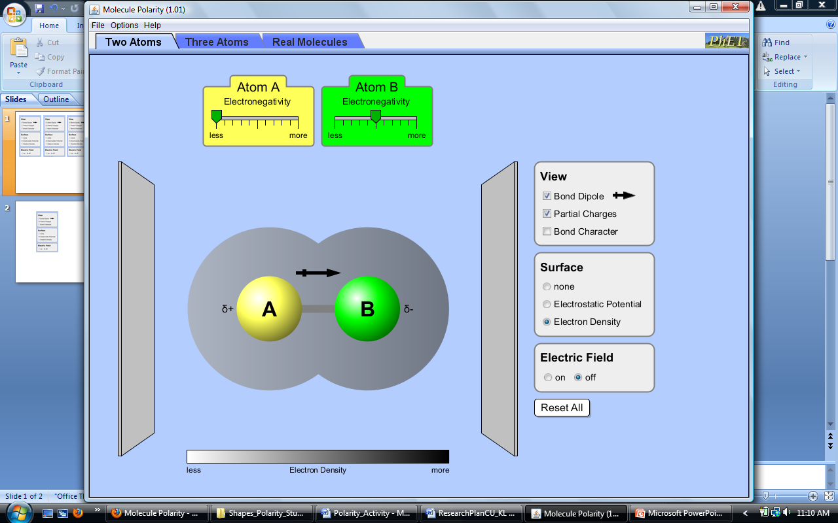





**Three Atoms** tab

1. Describe any new ways you can change the polarity of the three-atom molecule.
2. Explain the relationship between the bond dipoles and the molecular dipole.

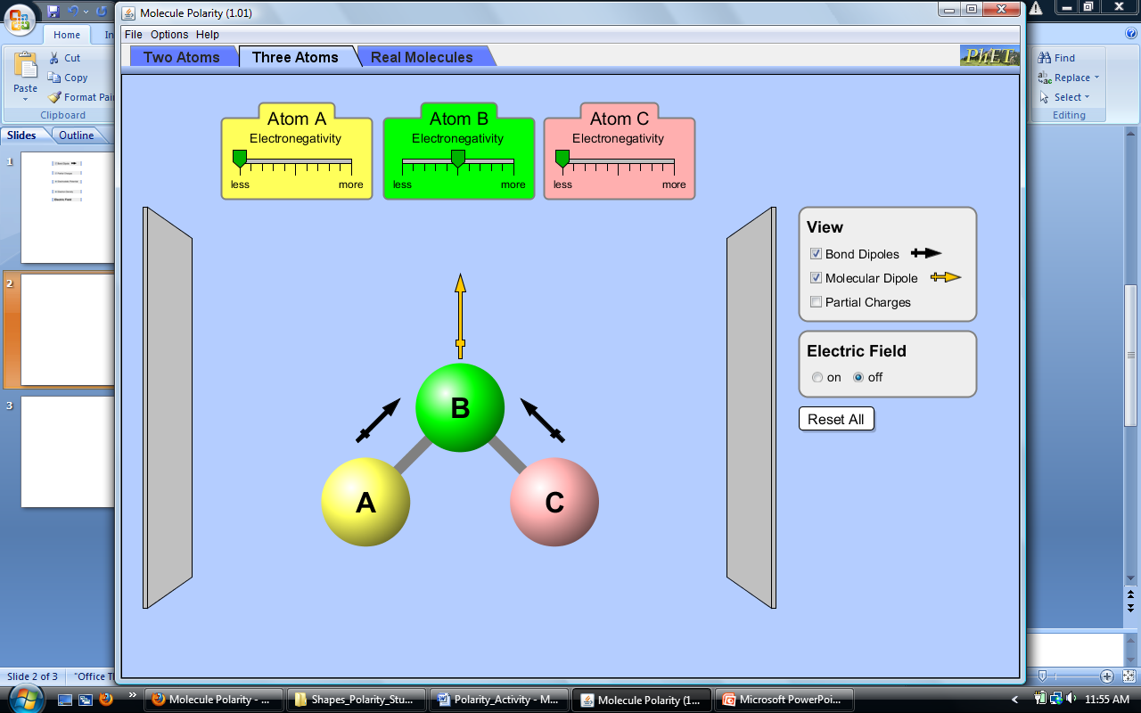

1. Can a non-polar molecule contain polar bonds? Explain your answer with an example.

**Real Molecules** tab

1. **Predict** the polarity of 6 real molecules. First, draw the molecules and any bond dipoles. Then draw any molecular dipoles. Explain your reasoning before you check your predictions with the simulation.