**Speed of a Wave Experiment**

**This activity supports the following unit and course objectives:**

(CLO4) Demonstrate knowledge of basic laboratory skills and operations in the areas of safety, measurement, chemical and physical properties of matter, atomic and molecular structure, chemical reactions, reactivity, structure, periodicity, and bonding.

Electromagnetic Energy (3.1)

* (3.1.1) Explain the basic behavior of waves, including traveling waves and standing waves (CLO1) (CLO3)
* (3.1.2) Describe the wave nature of light (CLO1) (CLO3)
* (3.1.3) Use appropriate equations to calculate related light-wave properties (CLO2)

**In addition to the unit and course objectives, this activity supports the following activity objectives:**

* Make claims about the relationships (direct, inverse, none) between wave variables, using evidence to support claims, and explaining the relationship between the claim and evidence. (3.1.1)
* Develop an equation that demonstrates the relationships between wavelength, frequency and speed of a wave (3.1.2) (3.1.3)
* Identify and define features of waves such as amplitude and period (3.1.1)

# Part A: Method for determining speed of a wave

**I. Initial Ideas:** Answer the following questions

* + What is a wave? Define “wave” in your own words.
  + What types of waves exist? How are these waves made? How are these waves similar and different?
  + Recall the word “speed”. What is speed? What equation(s) do we have for calculating speed? How can we measure the speed of a moving object?
  + We often talk about the *speed of sound* and the *speed of light*. Sound and light are two different types of waves. What do you think we mean when we talk about the “speed” of a wave

**II. Explore the PhET Sim: Waves on a String**

Directions:

* + Open the [Waves in a String Simulator:](https://phet.colorado.edu/en/simulation/wave-on-a-string) https://phet.colorado.edu/en/simulation/wave-on-a-string
  + Set up the sim:
  1. Select “no end”
  2. Adjust “Dampening” to zero

• Explore the sim. You have two challenges for your exploration:

* 1. Explore the controls and determine what types of variables you can modify.
  2. Develop a basic method for determining the speed of a wave on a string. Write a brief description of your method

# Part B: Variables Affecting the Speed of a Wave

1. **Anatomy of a Wave & Key Vocabulary** 
   * Sketch a wave and label *amplitude* and *wavelength.*
   * Define and describe the following terms: amplitude, wavelength, frequency, period, tension.
2. **Investigation 1: How can you increase the speed of a wave?** 
   * + Brainstorm a list of variables that you think might change the speed of a wave.
     + Select one variable that you believe affects the speed of a wave. Write a hypothesis that makes a claim about how your variable affects speed, and explains your reasoning for this relationship using the format of *“If…then…because…”.*
     + Test your hypothesis and record your observations using the following table or a table that you create:

|  |  |  |  |
| --- | --- | --- | --- |
| **Action** | **What changed?** | **How did it change?** | **Type of Relationship** |
| *What did you do? “Increased frequency”* | ▪ Speed   Frequency   Wavelength   Tension | *What did you observe?* | ▪ Direct   Inverse   None |

* + - Make a claim about whether or not your hypothesis was correct, using evidence from your lab to support your answer and explaining your reasoning.

1. **Investigation 2: How are other wave variables related?** 
   * + Investigate other relationships between variables and record your observations in the table above
     + Make claims about the relationship between two of the variables, providing evidence from your investigations to support your claim, and reasoning to connect your claim and evidence.

# Part C: New Equation for the Speed of a Wave

**Directions:** Answer the following questions

* Identify the wave variables that we measured to indicate length and time during the lab, then substitute these values into the speed equation to develop an equation for the speed of a wave.

|  |  |  |  |
| --- | --- | --- | --- |
| **Speed Quantity** | **Length Quantity** | **Time Quantity** | **Speed Equation** |
| Speed of a Moving Object | distance (d) | time (t) | 𝑑  𝑠 =  𝑡 |
| Speed of a Wave |  |  | *s* = |
| Speed of a Wave |  |  | *s* = |

* Frequency and wavelength are both in your equation for speed. Why is it that, when you changed the frequency, you did not change the speed of the wave?
* The only variable we found that affects the speed of a wave on a string was the tension of the string. How does this relate to how a musician tunes a stringed instrument?

**Interference Experiment**

**This activity supports the following unit and course objectives:**

Electromagnetic Energy (3.1)

* (3.1.4) Distinguish between line and continuous emission spectra (CLO1)
* (3.1.5) Describe the particle nature of light (CLO1) (CLO3)

Development of Quantum Theory (3.3)

* (3.3.1) Extend the concept of wave–particle duality that was observed in electromagnetic radiation to matter as well (CLO1)

**In addition to the unit and course objectives, this activity supports the following activity objectives:**

* Explain the phenomena of interference (3.1.4) (3.1.5) (3.3.1)
* Discuss the pattern obtained from a diffraction grating (3.1.4) (3.1.5) (3.3.1)

# Introduction to the Simulators:

Open the [Interference simulator web address](https://phet.colorado.edu/en/simulation/wave-interference) https://phet.colorado.edu/en/simulation/wave-interference

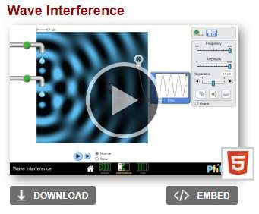

Click the play button launch the simulator

Familiarize yourself with their functions and widgets.

## **Part A: Open the “Wave Interference” simulator. Click on the option, “Waves.” “Laser”**

Experiment with the laser. What happens to the color when you change the frequency?

Use the measuring tape widget to estimate the wavelength of the light waves produced using the following frequency settings (don’t forget your units!):

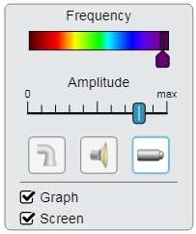 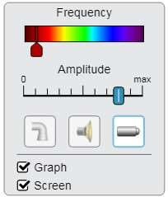

Wavelength: ____________ Wavelength: ________________

Now open a new tab in your browser and search for “wavelength of electromagnetic spectrum”.

What is the wavelength range for visible light (units!)? __________ to __________

**Part B:** Select the “Interference” option at the bottom-center part of your screen (see below):

Select the Laser option, and select the “Screen” option. Your screen should look something like this:

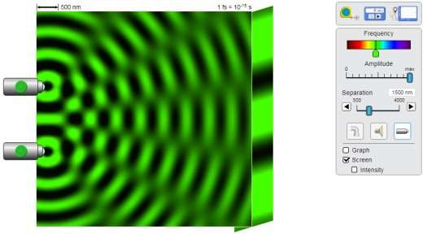

Identify the regions of constructive interference and destructive interference. Label the areas of destructive interference and constructive interference in the image below. *Please note, the dark patches of the wave do NOT indicate the absence of light!* On the “screen” however, the dark spots *do* represent areas of no light. This shows how the laser light would appear on a screen. (I know, it’s confusing. Perhaps black was not the best “trough” color choice…)

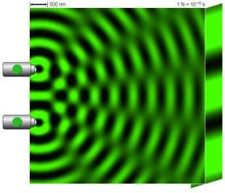

**Part C:** Select the “Slits” option at the bottom-center part of your screen (see below):

Your screen should look something like this:

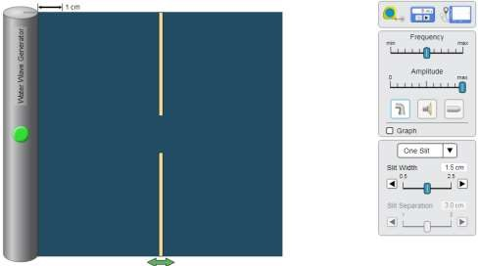

Predict what will happen when the wave reaches the break in the barrier, using your understanding of diffraction

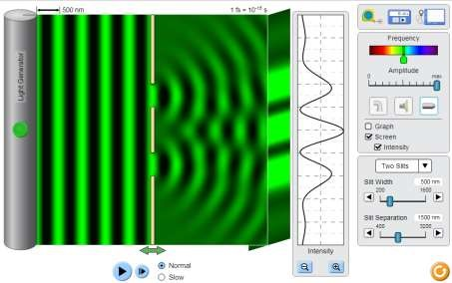

Now observe the effect of two slits using light waves. Two slits are used to create two new waves with the same amplitude, period, and frequency. This helps scientists observe how two such waves will interfere. Scientists have used two slits to prove that light acts as waves; diffracting and creating areas of interference just like water or sound.