**Title of assignment: Compare and Contrast**

**Length [to be filled out by instructor]: 3-5 pp**

**Due date [to be filled out by instructor]: TBA**

**SLO:**

1. **Define judgement and criteria that are appropriate to the objects of evaluation/comparison**
2. **Evaluate using these judgment and criteria**
3. **Produce a compare and contrast essay**

**Description of assignment:**

Compare and contrast essays and the objects, phenomena, and/or ideas that they describe are an important kind of paper—they offer a chance to see beyond binaries and to view things in a complex and nuanced way. So, for this assignment, we will choose two related subjects or subjects which are often grouped together and describe in detail their similarities and differences.

But in order to see in this nuanced way, it is important to see the objects of comparison for what they are—therefore, the sections on Evaluation will prove useful.

**Goal of assignment:**

The goal of this assignment is to see two subjects in a more rich and detailed way in order to uncover why these two subjects are often grouped together or why they should be. At the same time, this paper also asks you to see how these subjects are complex and should be viewed with all their nuances and differences. We are, in short, making a paper out of a Venn Diagram, where similarities and differences are described, as illustrated below, where the overlap between the circles signifies the similarities between two subjects.

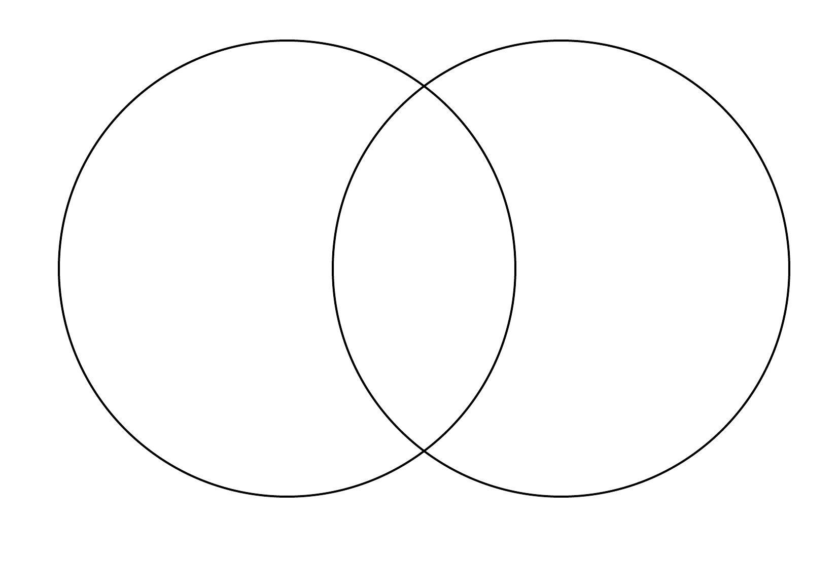

**Skills we will work on with this paper:**

--Observation and description

--Argumentation

--thesis creation

--Organization

--Use of transitional words

**Suggestions for topics:**

Historical Events: The French and American Revolutions

Technology and Social Media: Twitter and Facebook

People: Beyoncé and Madonna

Ideas: Evolution and Creationism

**Rubric [with percentage breakdown for different aspects of evaluation/grade (%)]:**

**Purpose & Supporting Details (30 points possible)**

**Clear contrast and comparison/**

**specific examples/relevant information 30 points**

**Clear contrast and comparison/**

**General examples/relevant information 20 points**

**Fairly clear contrast and comparison/ 10 points**

**General examples/includes non-relevant information**

**Incomplete contrast and comparison/**

**Missing examples/includes non-relevant information 5 points**

**Organization and Structure (30 points)**

**Organization follows consistent order, with logical**

**connections between similarities and differences 30 points**

**Organization doesn’t always follow a consistent order**

**but logical connections between and differences**

**are present 20 points**

**Organization doesn’t follow a consistent order**

**and logical connections are missing 10 points**

**Little sense that the comparison and contrast**

**is organized 5 points**

**Thesis (20 points)**

**Thesis explains the contrast and comparison,**

**highlights the importance of the comparison/contrast 20 points**

**Thesis explains the contrast and comparison,**

**gestures to the importance of the comparison/contrast 15 points**

**Thesis explains the contrast and comparison,**

**and the importance of the comparison/contrast**

**is implied 10 points**

**Thesis doesn’t explain contrast and comparison,**

**and makes passing reference to the importance of the comparison/contrast 5 points**

**Grammar and Formatting (20 points)**

**no errors in grammar or spelling that**

**distract the reader from the content,**

**MLA formatting is correct 20 points**

**A few errors in grammar or spelling that**

**distract the reader from the content,**

**MLA formatting is correct 15 points**

**Multiple errors in grammar or spelling that**

**distract the reader from the content,**

**Some MLA formatting is incorrect 10 points**

**Errors mostly distract the reader from content,**

**MLA formatting is missing or mostly incorrect 5 points**

**Possibilities (the best essays do this):**

--present a logical and connected discussion of similarities and differences, avoiding lists of things that are similar or dissimilar

--choose subjects to compare and contrast that are similar enough to warrant the comparison and different enough to create a compelling argument.

--make clear the “so-what” of the essay—why does this comparison and contrast matter? The most advanced essays address the relevance of these comparisons and contrasts in explicit and implicit ways

**Perils (common mistakes students make with this assignment):**

--a data dump of similarities and differences that appear as lists

--choosing things that are too different or too similar

--not addressing why these similarities and differences are important