**Friction and Acceleration**

**This assignment supports the following Course Goals, Course Learning Outcomes, and Unit Objectives**:

* Explain and apply Newton's first, second, and third laws. (CLO1)(CLO2)(CLO3)
* Identify various forces in a diagram or problem (CLO2) (CLO3)
* Translate a free-body diagram into a mathematical representation. (CLO2)(CLO5)
* Calculate mass, weight, and force (CLO2)(CLO5)
* Explain what is meant by normal force. (CLO2)(CLO3)
* Explain the role that inertial plays in effecting motion (CLO2)(CLO3)
* Discuss the requirements for and consequences of balanced and unbalanced forces (CLO2)(CLO3)
* Calculate the net force acting on objects and their resulting accelerations. (CLO2)(CLO5)

*Write* *out* *a* *definition* *for* *each* *term* *below.*

Newton's First Law of Motion-

Newton's Second Law of Motion-

Newton's Third Law of Motion-

Friction –

Static Friction –

Kinetic Friction –

Open up the University of Colorado, PhET "Forces and Motion" simulation [http://phet.colorado.edu/en/simulation/forces-and-motionbasics](http://phet.colorado.edu/en/simulation/forces-and-motion-basics)

Spend a few minutes familiarizing yourself with the controls of the simulation before you begin the lab below.

**Part I (Friction):**

Click on the Friction Tab and check all the boxes in the upper right hand corner

(Forces, Sum of Forces, Values, Masses, Speed)

1. place 40 kg girl on the screen. Type in the box for the applied force 150 N. The screen should look like:

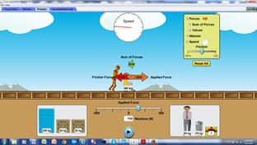

1. Read the friction force and then calculate the weight of the girl.
2. Repeat (a) and (b) for other objects and construct a table like the one shown below:

|  |  |  |  |
| --- | --- | --- | --- |
| Mass of Object (kg) | Applied Force (N) | Friction (N) | Weight of Object = Normal Force |
| 40 | 150 |  |  |
| 50 | 200 |  |  |
| 80 | 250 |  |  |
| 100 | 300 |  |  |
| 150 | 400 |  |  |

1. Plot a graph of Friction vs. Normal Force and find the slope of the graph.

1. What does the slope of the graph represent?

1. what is the unit of the slope, if any?

1. Challenge Question:

What is the mass of the gift box? Explain how you got your answer.

**Part II (Acceleration):**

Click on the Acceleration Tab and check all the boxes in the upper right hand corner (Forces, Sum of Forces, Values, Masses, Speed, and acceleration). Don't change the friction scale shown on your screen

1. Place 50 kg box on the screen. The screen should look like:

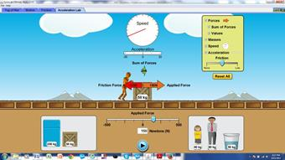

Type in the box for the applied force 150 N and calculate the time it will take for the box to go to the maximum speed. The maximum speed is reached when the hand on the speedometer cannot go any further.

Open a new browser (for the purpose of measuring the time it will take for the box to go to the maximum speed) and click on the link below for the stop watch. http://www.online-stopwatch.com/full-screen-stopwatch/

You will see something similar like:



1. Find the net force from the animation and calculate the acceleration of the box by using the equation a = v/t. Use an average speed of 40 m/s
2. Repeat (a) and (b) for applied forces of 200 N, 250 N, and 300 N.
3. Record your answers as shown in the table below:

|  |  |  |  |  |  |
| --- | --- | --- | --- | --- | --- |
| Applied Force (N) | Net Force (N) | Mass (kg) | Time (sec) | Average  Speed  (m/s) | Acceleration (m/s2) |
| 150 |  | 50 |  | 40 |  |
| 200 |  | 50 |  | 40 |  |
| 250 |  | 50 |  | 40 |  |
| 300 |  | 50 |  | 40 |  |

1. Plot a graph of Net Force (N) vs. Acceleration (m/s2).
2. Find the slope of the graph. What does the slope represent?
3. Find % error of the mass of the object.

Conclusion: Write a short conclusion of what you have learned from this activity